Withdrawal and Academic Failure in OULAD
  - Stakeholder briefing October 2026

The core problem
More than half of enrollments ended in withdrawal or failure
• Withdrawal and failure together accounted for 52.80% of enrollments: 17,208 out of 32,593. Withdrawal represented 31.16% and failure 21.64%.
• Overall success, including distinction, was 47.20%. The study covers 28,785 students across 7 modules and 22 presentations in 2013 and 2014.
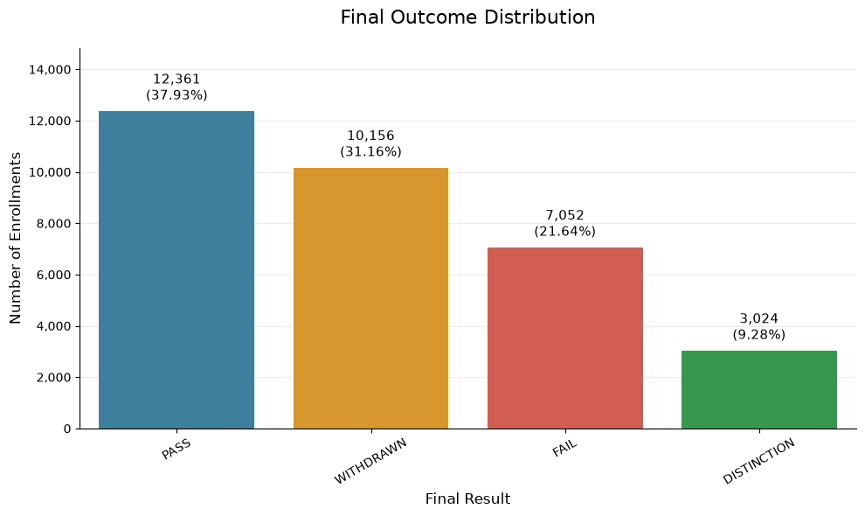
Figure 1 Final outcomes across all enrollments
Reading guide: PASS means a pass without distinction; DISTINCTION is a higher achievement category; FAIL means failure; WITHDRAWN means withdrawal. Overall success combines PASS and DISTINCTION.
The unit of analysis is one student enrollment in a specific module presentation. A student may have several enrollments. The following sections identify potential contributing factors and support needs; the findings describe associations and do not establish causality.

1 Modules with the greatest support needs
• Combined withdrawal and failure rates were 62.16% in CCC, 58.39% in DDD, 53.00% in FFF and 52.54% in BBB, compared with 43.76% in EEE, 40.25% in GGG and 29.01% in AAA.
• CCC and DDD had the highest combined rates. BBB and FFF had the largest numbers of affected enrollments: 4,155 and 4,114, respectively.
• GGG had the highest failure rate, at 28.73%, despite withdrawal of only 11.52%. Academic performance support is therefore important alongside retention efforts.
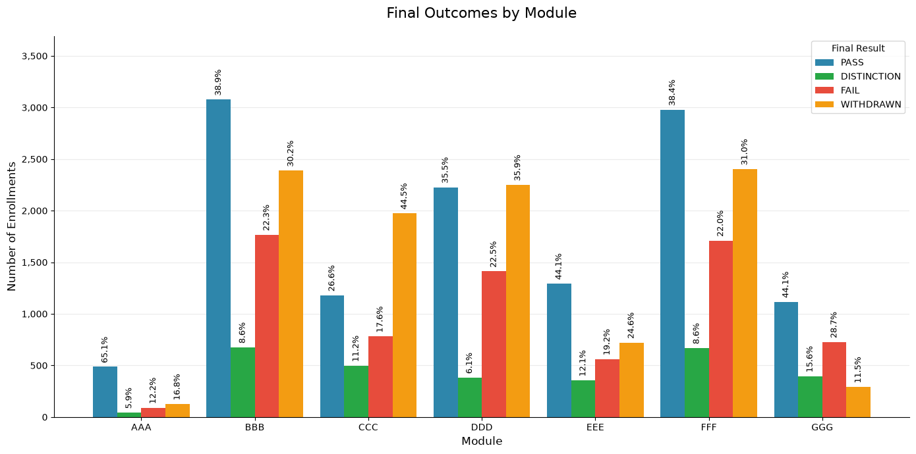
Figure 2 Final outcomes by module
Percentages use enrollments within each module as the denominator; bars show counts. Combined rates were calculated from the original counts and may differ slightly from the sum of rounded percentages.

Proposed support for affected groups
• CCC and DDD: Review study requirements and assessment sequencing, and contact students early to understand difficulties with continuing their studies.
• BBB and FFF: Allocate advisers and support sessions in proportion to the volume of cases.
• GGG: Explain difficult concepts, provide practical exercises and help students prepare for assessments.

2 When withdrawals occurred
• There were 2,676 withdrawals before teaching began, representing 26.35% of all withdrawals. Another 2,356 occurred during days 0–27, accounting for 23.20%.
• Together, 49.55% of withdrawals occurred before the end of the first four weeks. A further 49.54% occurred from day 28 onward. Timing was unknown for 93 enrollments, or 0.92%.
• These findings support preparation before the course starts, intensive early follow-up and continued support beyond the first month.
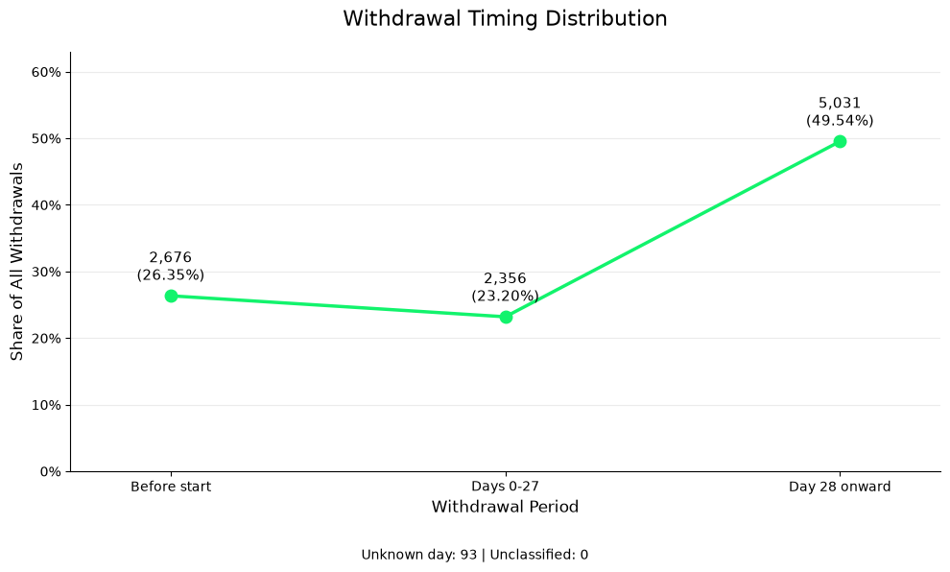
Figure 3 Withdrawal timing before and during the course
The denominator is all 10,156 withdrawals. The periods differ in length, so the line does not represent a daily withdrawal rate or an equal-duration weekly comparison.

Proposed support for affected groups
• Before teaching starts: Explain course requirements and expected study time, and check that students can access the platform.
• First four weeks: Follow up with students who have not started activities or have missed submissions, and offer direct assistance.
• Beyond the first month: Continue monitoring before major assessments and when sustained declines emerge.

3 Study load and final outcomes
• Combined withdrawal and failure rose from 48.20% among enrollments with 1–60 studied credits to 58.58% at 61–120 credits and 69.64% above 120 credits.
• The increase was mainly in withdrawal, which rose from 25.35% to 51.29%. Study load refers to the total credits a student was studying at the time of enrollment.
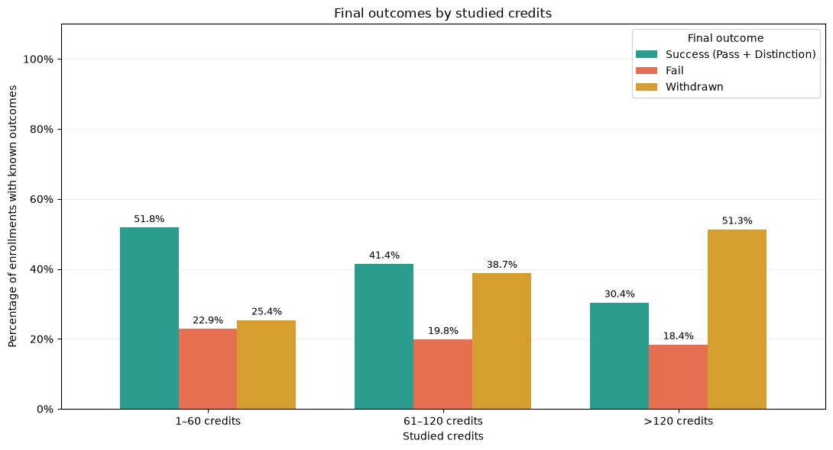
Figure 4 Success failure and withdrawal by study load
• Withdrawal increased with study load within all seven modules. Comparing the lowest and highest load bands, it rose from 37.22% to 62.84% in CCC and from 28.59% to 60.08% in DDD.
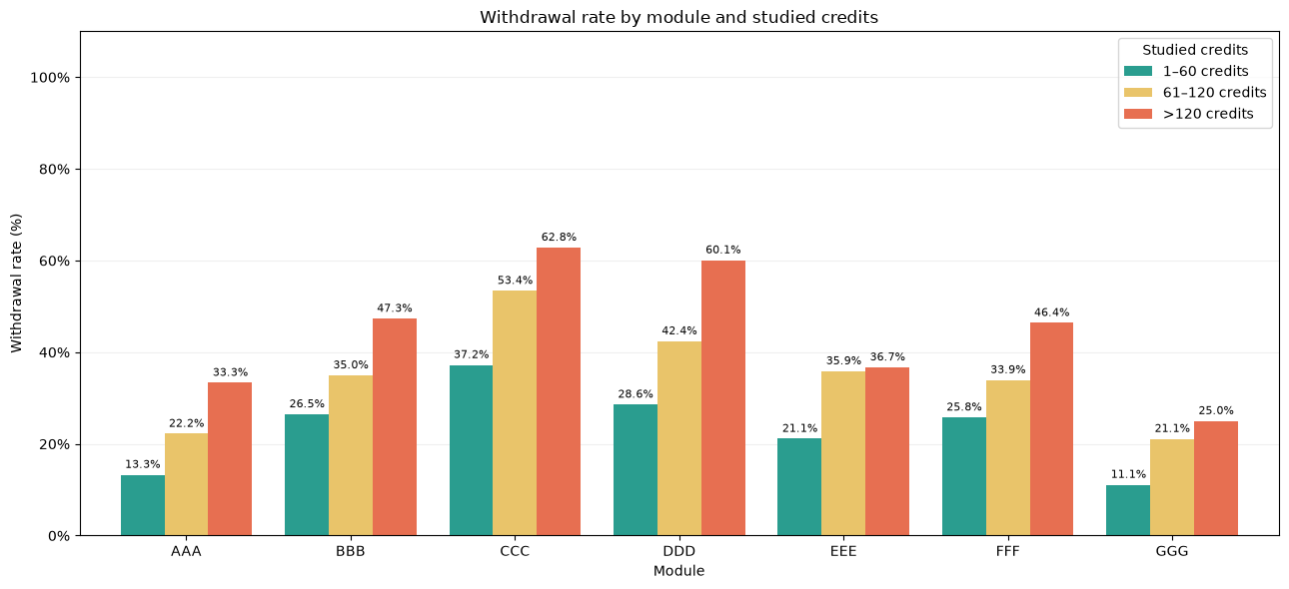
Figure 5 Withdrawal by study load within each module

Proposed support for affected groups
• Review study load: Check whether the credit load fits the student’s available time and other commitments, especially above 120 credits.
• Plan study time: Develop a weekly schedule, spread out submission tasks and allow load reductions or adjustments where regulations permit.
• Before enrollment: Offer individual advice to students planning a high study load.

4 Previous attempts at the same module
• Combined withdrawal and failure were 66.92% among enrollments with previous attempts, compared with 50.72% among those without: a gap of 16.20 percentage points.
• Failure was 31.66% versus 20.16%, and withdrawal was 35.26% versus 30.56%. The groups contained 4,172 enrollments with previous attempts and 28,421 without.
• Students repeating a module may benefit from structured follow-up that addresses unresolved difficulties from their earlier attempt.
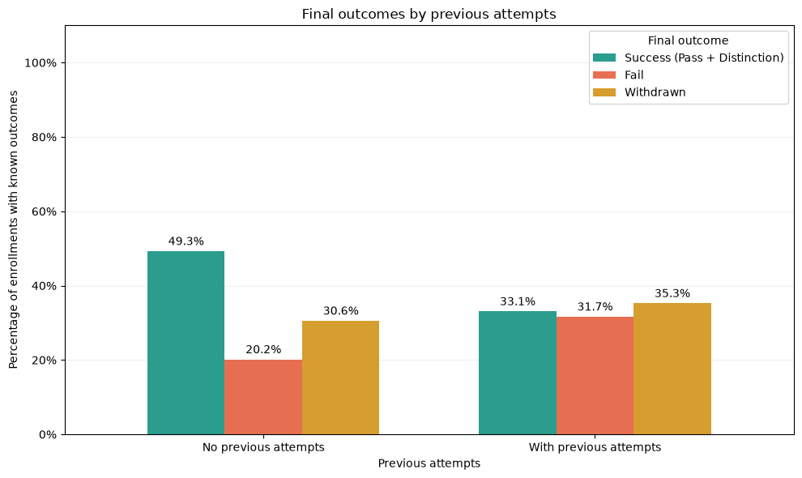
Figure 6 Outcomes with and without previous module attempts
This comparison distinguishes any previous attempt from none. It does not demonstrate that each additional attempt produces a similar increase in difficulty.

Proposed support for affected groups
• Identify learning gaps: Use a short diagnostic assessment to identify difficulties that remain from the previous attempt.
• Build a repeat-study plan: Set clear goals, provide targeted practice and arrange regular adviser follow-up.
• Review progress: Reassess performance after the first assessment and adapt support to the student’s needs.

5 Deprivation and regional differences
• Combined withdrawal and failure were 64.84% in the most deprived IMD band, 0–10%, compared with 42.47% in the least deprived band, 90–100%.
• In North Western Region, 37.9% of enrollments were in the most deprived 0–20% bands, alongside a combined withdrawal and failure rate of 59.81%. In South Region, the corresponding figures were 5.9% and 47.61%.
• Deprivation alone does not explain regional differences. Wales had the highest regional failure rate, at 29.72%, despite a lower concentration of deprivation than North Western Region.
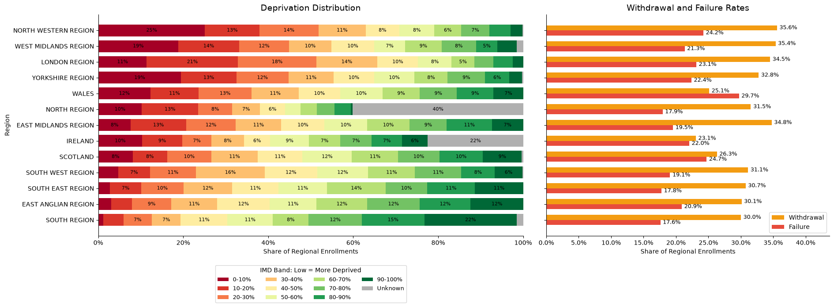
Figure 7 Deprivation bands and outcome rates by region
Lower IMD bands indicate greater deprivation. The chart describes project enrollments, not regional populations. Missing deprivation data for 40.1% of North Region enrollments and 22.5% in Ireland limit comparisons.

Proposed support for affected groups
• Identify barriers: Check connectivity costs, access to devices and difficulties reaching support services.
• Improve access: Offer downloadable, low-data materials, flexible support hours and referrals to available assistance.
• Allocate resources: Prioritize areas with greater needs while assessing each student’s circumstances individually.

6 Prior educational attainment
• Combined withdrawal and failure were 70.32% among enrollments with no formal qualifications and 61.15% among those below A Level, compared with 47.97% for A Level or equivalent.
• The combined rate fell to 43.83% for higher education qualifications and 34.50% for postgraduate qualifications.
• These findings support reviewing academic preparation and foundational skills needs. The no-formal-qualification and postgraduate groups were relatively small, with 347 and 313 enrollments, respectively.
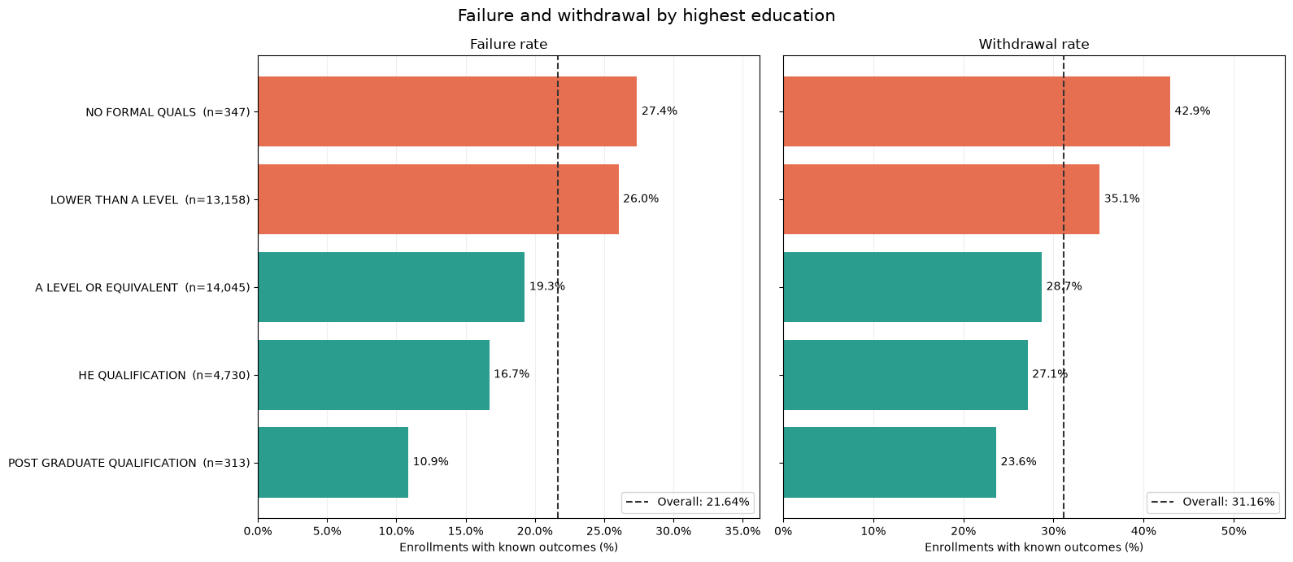
Figure 8 Failure and withdrawal by highest prior qualification
Dashed lines show the overall rate for each outcome. Differences should also be considered alongside module mix, study load and previous attempts.

Proposed support for affected groups
• Strengthen academic preparation: Offer introductory units in study skills, academic writing, numeracy and digital skills.
• Assess individual needs: Use a diagnostic assessment to identify the skills each student needs to develop.
• Provide gradual practice: Use worked examples, progressively demanding exercises and feedback, especially early in the course.

7 Assessment completion across modules
• Of eligible assessment opportunities, 22.93% had no submission record. Mean completion per enrollment was 43.67% for failure and 58.17% for withdrawal, compared with 95.52% for pass and 96.68% for distinction.
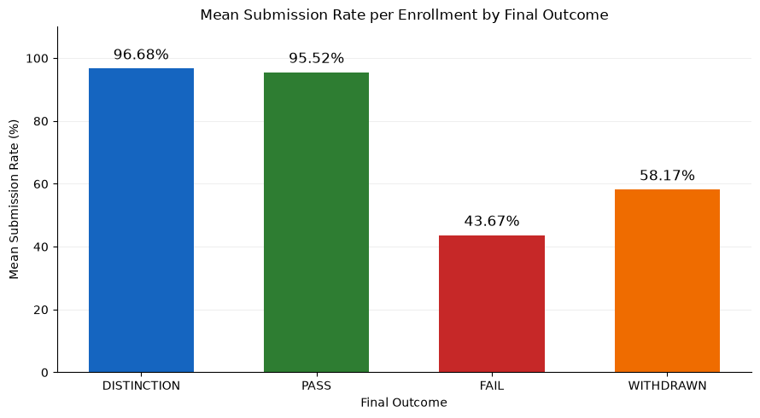
Figure 9 Mean assessment completion per enrollment by outcome
• The shares of assessment opportunities with a submission record, for failed and withdrawn enrollments respectively, were: AAA 63.2% and 70.1%; BBB 43.2% and 57.4%; CCC 46.2% and 60.6%; DDD 50.4% and 61.6%; EEE 34.7% and 51.8%; FFF 35.9% and 60.5%; GGG 28.3% and 57.3%.
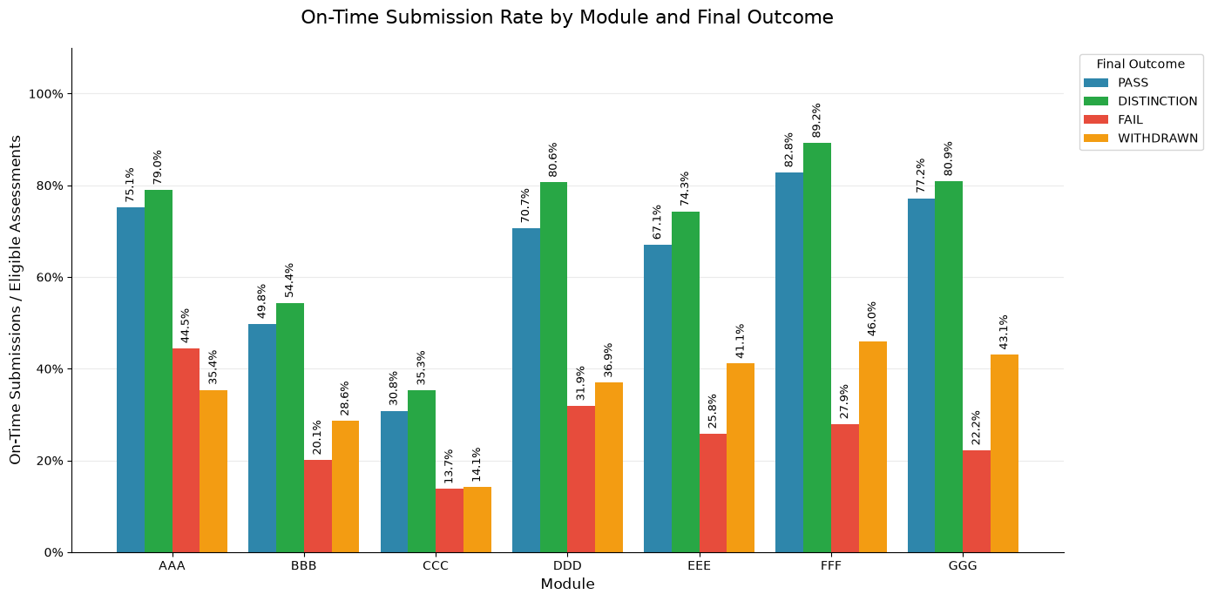
Figure 10 On-time submissions as a share of eligible assessment opportunities by module
Module percentages are assessment-opportunity rates, unlike the enrollment averages in Figure 9. Figure 10 measures on-time submission specifically. For withdrawn enrollments, only assessments due before withdrawal are included. Missing submission records require a data-completeness check.

Proposed support for affected groups
• Follow up early: Provide a clear assessment calendar and reminders, and contact students about missing expected submissions after checking record completeness.
• Make tasks manageable: Break large assignments into stages and explain task requirements and marking criteria in support sessions.
• Prioritize modules: Review completion gaps in GGG, EEE and FFF, and difficulties meeting deadlines in CCC.

8 Early engagement with learning resources
• During days 0–27, median active days were 11 for pass and 14 for distinction, compared with 7 for failure and 8 for withdrawal.
• Within modules, median active days for pass, failure and withdrawal, respectively, were: AAA 14, 7, 12; BBB 8, 5, 6; CCC 11, 7, 8; DDD 14, 8.5, 9; EEE 12, 7, 7; FFF 16, 9, 12; GGG 4, 3, 3.
• Engagement should be interpreted in the context of each module. In AAA, median clicks for withdrawal and pass were similar, at 275 and 279.5; activity volume alone is therefore insufficient.
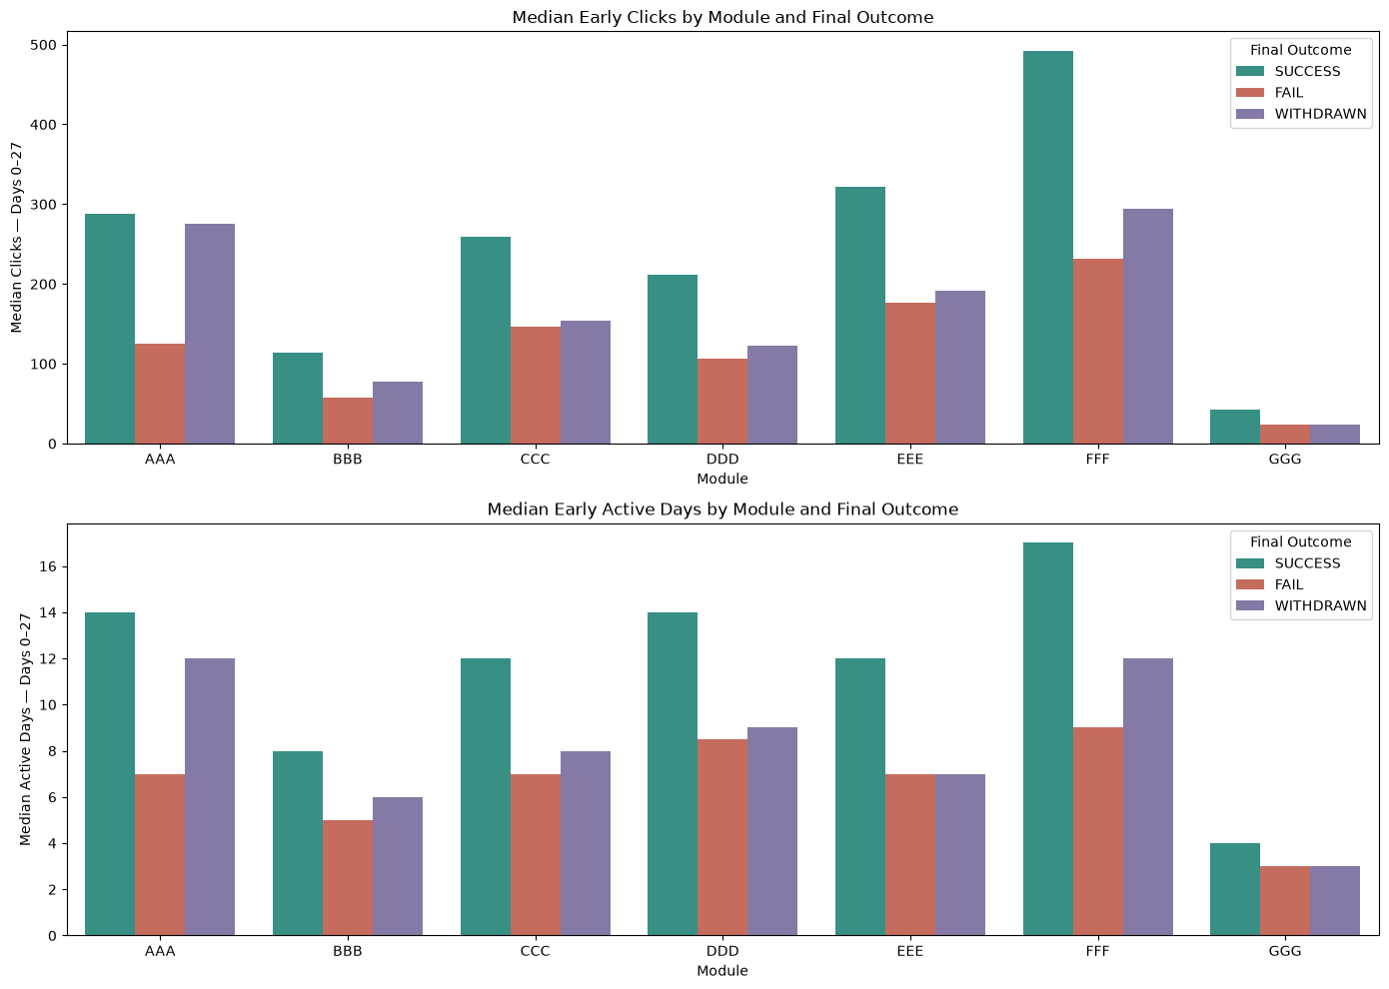
Figure 11 Median early clicks and active days by module and outcome
The chart covers 26,754 full-window eligible enrollments with interaction records and combines PASS and DISTINCTION as SUCCESS. Pass figures in the text refer to PASS alone. Engagement measures exclude 475 eligible enrollments without records; these were not automatically treated as zero activity.

Proposed support for affected groups
• Establish a clear starting point: Identify essential first-week resources and activities and connect them to assessments.
• Make individual contact: Ask students with low activity about technical or study difficulties and limited time.
• Use module-specific expectations: Interpret activity against the module’s own patterns rather than applying one universal click threshold.

9 Weekly engagement patterns
• The success group generally showed higher weekly engagement. In week 3, mean clicks were 94.53 for success, 70.42 for withdrawal and 57.22 for failure.
• By week 4, the averages had fallen to 72.29, 46.38 and 38.40, respectively. Changes should be interpreted alongside teaching and assessment schedules, rather than using a single week in isolation.
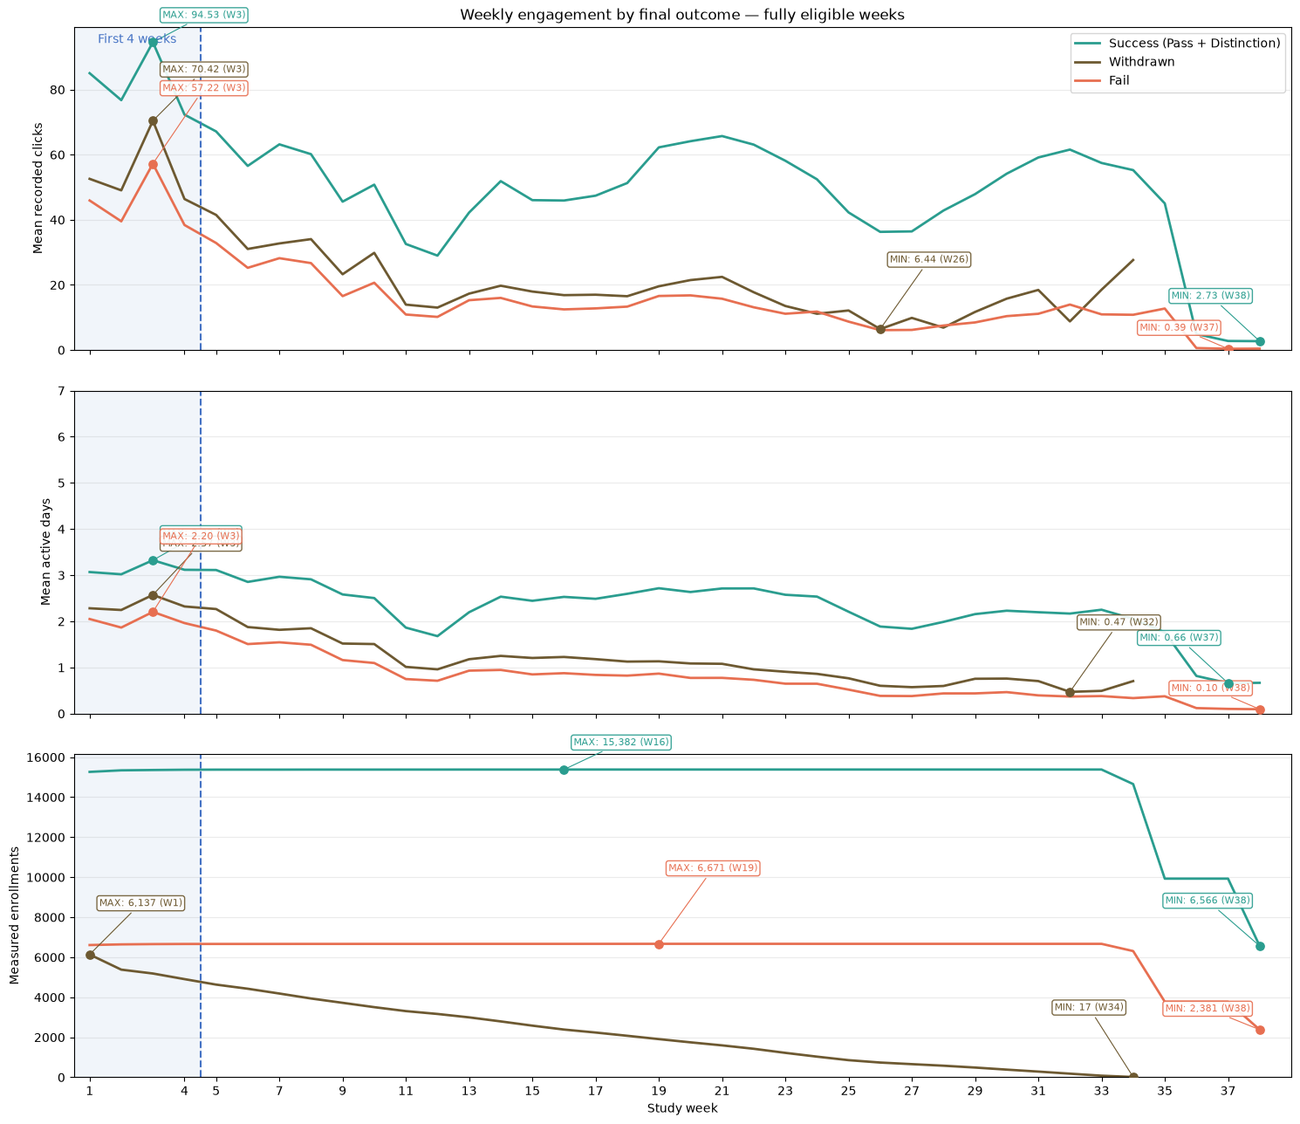
Figure 12 Weekly clicks active days and measured enrollment counts
The measured sample changes each week with enrollment eligibility and withdrawal; the lines do not track the same individuals over time. Means include zero-activity weeks for enrollments with interaction records. The withdrawal line ends when no eligible weeks remain.

Proposed support for affected groups
• Monitor changes: Look for sustained declines relative to each student’s earlier activity, allowing for the module calendar.
• Help students regain momentum: Offer supportive contact, a short discussion and a follow-up plan where needed.
• Support assessment preparation: Arrange revision sessions, then review activity and submissions after support is provided.

10 Engagement and submission together
• Success was 69.35% when both engagement and submission were high, compared with 22.82% when engagement was high but submission was low.
• Success was 50.27% with low engagement and high submission, and 10.83% when both were low. Using the two indicators together can help identify support needs.
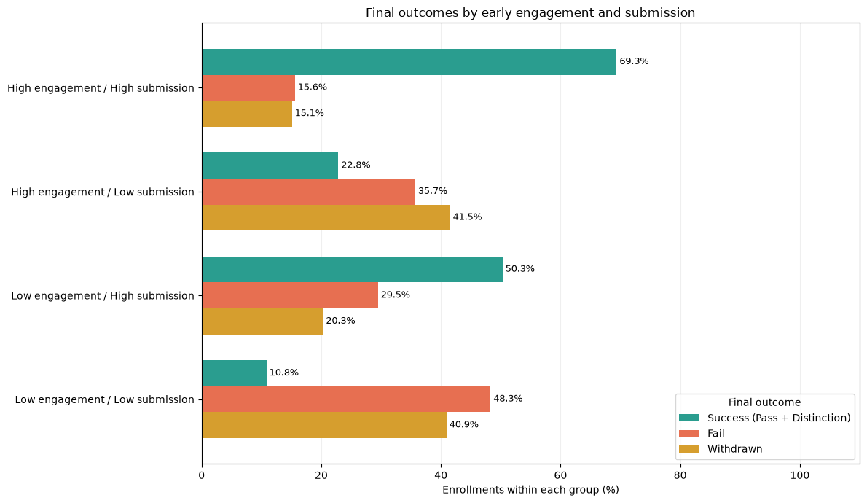
Figure 13 Outcomes by early engagement and assessment submission
Measures cover days 0–27. High engagement means positive clicks at or above the presentation median. High submission means completing at least 80% of assessments due in the window by day 27.
The comparison includes 21,533 enrollments in AAA, BBB, CCC, DDD and FFF, excluding EEE and GGG. The high-engagement, low-submission group contains only 241 enrollments. These are exploratory thresholds, not validated alert rules.

Proposed support for affected groups
• High engagement and low submission: Help students understand assessment requirements, manage time and complete the task.
• Low engagement and high submission: Review grades, learning quality and study methods before deciding on an intervention.
• Both low: Prioritize individual contact to explore technical, academic and personal barriers.
• Both high: Continue routine monitoring and offer suitable enrichment activities.
Evaluate support: Pilot actions on a limited scale and track assessment completion, retention and success. Before expanding, assess changes in combined withdrawal and failure using comparable groups within the same module and presentation.

Action priorities
Focus support on CCC and DDD, provide capacity for the case volumes in BBB and FFF, review high study loads and previous attempts, and monitor submission and engagement together.
Source for all figures and results: saved outputs in Final_OULAD_Analysis_EN(1).ipynb. Original notebook charts are reproduced. Combined indicators were calculated from the original counts; minor differences may arise from rounding.

